Title: Access to QGIS

What you will learn:
- To install QGIS on your laptop or PC
- An introduction to the QGIS Graphical User Interface (GUI)

Resources:
- Link to QGIS webpage https://www.qgis.org/en/site/
Laboratory Exercise:
All your laboratory exercises will be performed using the QGIS platform. The introduction to GIS video, later in our course, will provide you with basic information about GIS and the types of data that you will be working on in the semester. The QGIS software is installed in AESB 220 which you can remotely access if you are off campus or if you do not have a personal PC/laptop. However, it is highly recommended that you also install the software on your personal PC for convenience. QGIS can work on both Windows and MacOS machines, but the instructions in our lab modules are intended for Windows machines only. They should not differ significantly for MacOS.

In this exercise, you will:
- Download the QGIS software and install it on your computer.
  - OR remotely access the computers in AESB 220 and try to open QGIS.
- Open QGIS and be familiar with the components of its graphical user interface (GUI).

Deliverables: There are no deliverables for this lab. Just make sure that you have successfully installed QGIS or can remotely access QGIS and can open the software without any error messages. Also, be familiar with the parts of the QGIS GUI as they will be referenced in the next laboratory exercises.

Procedure:

PART 1. Install QGIS or remotely access QGIS
1. Download the appropriate QGIS installer from https://www.qgis.org/en/site/forusers/download.html. Take note that there are different versions of the installer (e.g., Windows or MacOS). Download QGIS 3.3x or whatever latest version is available (see below).

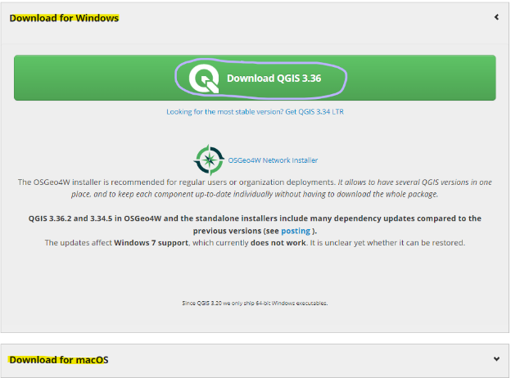

2. Go to the “Downloads” folder of your computer and double-click on the QGIS-OSGeoxxxx.msi file (see below) to install

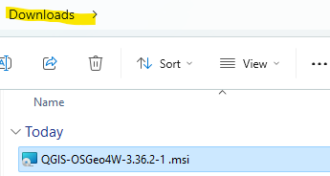

3. Follow the instructions on the setup wizard. Check the option for creating a desktop and start menu shortcuts (see below).

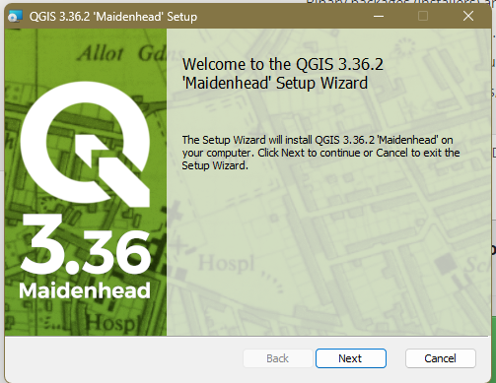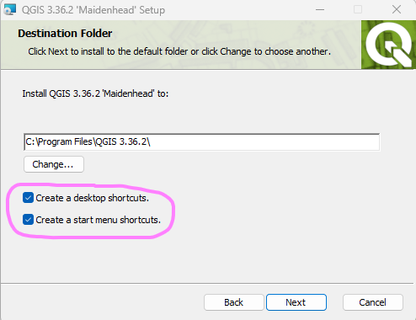

4. If you do not have a PC or prefer to remotely access QGIS from AESB 220 computers,
use UIUC AnyWare:

UIUC AnyWare overview: https://answers.uillinois.edu/illinois/105054
Connecting to UIUC AnyWare: https://answers.uillinois.edu/105108

PART 2. Introduction to the QGIS interface

1. Open QGIS. The way you open QGIS will vary depending on your operating system. For this exercise, I am using Microsoft Windows 11 OS. To open QGIS, go to start, search for QGIS, and double-click on QGIS Desktop (see below). If you created a shortcut on the Desktop, open the QGIS folder and double-click on QGIS Desktop 3.3x (see below).

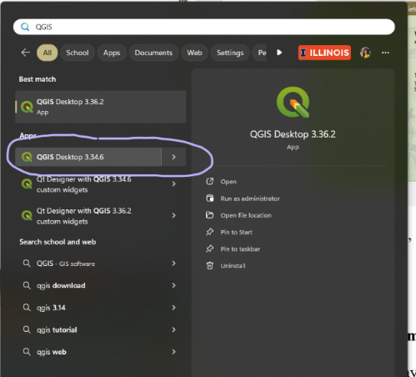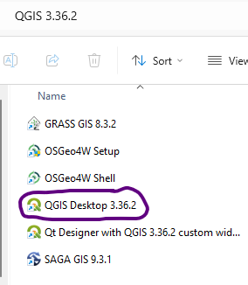

3. Explore the QGIS GUI. The interface of QGIS is straightforward. The Browser and Layer panels are docked to the left side (see below) while the right is taken by the Map View (aka Map Canvas). Above are the toolbars and menus and below are the status and locate bars. When you first launch QGIS, you will see the recent projects and the project template (left figure below). These will be replaced by the map view once you open a file or map. The GUI can be rearranged to the user’s preference. There are many panels and toolbars in QGIS that can be made visible and/or located in the different parts of the GUI. Right-click on the menu bar to see the available ones. Also, on the Browser or Layer panels, make a right-click on a file to access its context which contains many options.

Hover the mouse over the menu and toolbars to see their descriptions. Try clicking or right-clicking them to see their context. Explore the QGIS GUI.
